Samarth Narula

Roll Number: M2022DS043

Guide: Parthasarathi Mondal

Coordinator: Prarthana Saikia

Course: MA Development Studies

Due Date: 7th February 2024

Echoes of Self: An exploration of Vipassana

1. **Primary Objective**

The primary objective of this thesis is to comprehensively examine the impact of Vipassana meditation on self-perception and interpersonal relationships within the framework of contemporary societal dynamics.

**Sub-objectives include:**

Analyzing the concept of self as it is influenced by Vipassana meditation, through organic breakdown of interview data.

Investigating the effects of Vipassana meditation on introspection, empathy, spirituality, and sensation-awareness, and their implications for personal and social relationships.

Examining the social implications of Vipassana, particularly how retreat experiences shape the “self” away from the social.

**2. Rationale**

The decision to investigate Vipassana was inspired by both intellectual curiosity and a profoundly personal quest. Having engaged in Vipassana practice, I can attest to both its transforming potential and the concomitant struggles. Because of this link, I've become more invested in studying Vipassana from an academic perspective.

In addition, I was fascinated by the philosophical aspects of self-observation as I was engaged in practice. What happens when a person looks inward and treats themselves like an object in a museum? Does one undergo a radical change in awareness or self-perception? The idea of maitri, or unconditional love, proposed by Vipassana was just as interesting. While presented as a core tenet, its actual realisation often felt nebulous, challenging me to question its authenticity and the conditions under which such a profound sentiment could genuinely arise.

My interest in Vipassana thus, arose at a time when "self-care Sundays" were trending on social media and when meditation had been reduced to a 10-minute break on a smartphone app (Flood, 2019). The promise of a more in-depth, long-term journey towards self-awareness stood in stark contrast to the quick fixes for improving one's life that saturated my online environment (Duffy & Hund, 2015). This dissertation was inspired in part by my own investigation into whether and how alternative healing modalities like Vipassana fit into (or conflict with) the modern self-care narrative (Hart, 2020) (Duffy & Hund, 2015).

As I progressed in my practice, I encountered personal struggles. There were times when the Vipassana moral rules or teachings seemed at odds with my own personal experiences and emotions. Instead of putting me off, this conflict fueled my interest in learning more about the nuanced nature of Vipassana, both as a personal practice and a field of study (Duffy & Hund, 2015) (Hart, 2020).

**3. Research Questions & Initial Concepts**

**3.1** How does Vipassana facilitate an individual's process of self-examination, particularly in terms of the self becoming both the subject and object of introspection?

Concepts: Deconstruction of the Self, Impermanence, Awareness, Care of the Self and Subject-Object Duality, Morality, and Knowing Oneself.

Note: This basic question explains the contemplative practice of Vipassana and connects it directly to the ideas of self-reflection and self-constitution put forth by Foucault (“Stanford Encyclopedia of Philosophy,” 2001).

**3.2** Through Vipassana, how is an individual's dual relationship—as both subject and object—with their own 'self' transformed, and how does this transformation affect their sociality towards others?

Concepts: empathy, anchoring in vipassana, sensations, spirituality, self-to-self and self-to-other relations, and subject-object continuity.

Note: By highlighting the subject-object duality in this question, Vipassana is presented as a tool for both personal transformation and reshaping one's perception of their role in social dynamics (“Stanford Encyclopaedia of Philosophy,” 2001) (Ambedkar, 2011).

**3.3** In positioning itself away from conventional social contexts, how does Vipassana influence an individual’s perceptions of sociality?

Concepts: The Social 'Away from the Social', Controlled Environmental Influence, Relational Empathy, Maitri (Loving Kindness)

This inquiry pertains to the paradoxical nature of Vipassana, which is a practice that is often perceived as being detached from social interactions, yet it has the capacity to cultivate deep and meaningful social bonds (Ambedkar, 2011).

**Chapter 2: Research Methodology**

* + 1. **Introduction to Methodology:**

In the pursuit of unravelling the intricacies of Vipassana—a practice that juxtaposes the rigour of "scientific" inquiry with profound spiritual resonance—the choice of methodology becomes paramount (*SN Goenka’s Discourses*, n.d.). Guided by the framework of the "self," the chosen methodology seeks to illuminate various nuances; however, it is crucial to emphasise at the outset that this study does not begin with a definitive claim regarding Vipassana's transformative potential. Instead, it positions itself as an open-ended exploration, allowing the qualitative interview data to emerge organically and speak for itself.

The decision to include conversational interviews was not solely an academic one but rather emerged from a sincere desire to actively connect with the real-life experiences of Vipassana practitioners (Hart, 2020). This particular approach, distinguished by its inherent openness and adaptability, facilitated a natural examination of the intricacies and possibilities for transformation linked to the given practice (*SN Goenka’s Discourses*, n.d.) (Atsadonsak et al., 2020).

Moreover, this methodology exhibited a reflexive shift, fulfilling a double objective. On one side, it served as a mechanism for establishing connections with individuals, facilitating the process of actively engaging with and comprehending their own experiences within the context of Vipassana meditation (Aycock, 2006) (Goenka, 2012). However, it offered a perspective that encouraged me to engage in introspection and critically examine my own experiences and perceptions. Reflexivity, an inherent characteristic of qualitative research, contributes to the thoroughness and genuineness of the investigation, guaranteeing that, as a researcher, I am not detached but profoundly immersed in the essence of the study (Atsadonsak et al., 2020).

The research process is greatly aided by the clarity and openness afforded by a well-defined methodology section. By detailing the strategies used, the decisions made, and the reasoning behind those selections, this part provides readers with a road map that helps them follow along with the investigation. It also guarantees the research's rigour and validity, which adds to the study's trustworthiness (Aycock, 2006). The methodology guides the direction of the investigation and provides a firm foundation for the findings.

**2. Rationale for Methodology:**

**2.1** **Foucault's core beliefs** regarding individuality and the development of the self are best expressed by Nietzsche's claim that there is no "general view" (Anderson, 2005). Vipassana, as a method of introspection, is consistent with Foucault's ideas of self-care and critical thinking.  By taking a qualitative approach, we may delve more deeply into the ways in which Vipassana may serve as a "technology of the self," shaping and forming the identities of its practitioners (Goenka, 2012). Buddha's teachings are highly idiosyncratic, as Dr. Ambedkar explains in "Buddha and His Dhamma," with each follower following his or her own road to enlightenment (Murphy, 2000).

"The main interest in life and work is to become someone else that you were not in the beginning." Michel Foucault

**2.2** **The Buddhist teachings** on the nature of life are consistent with Heidegger's idea of being "thrown" into the universe (Ambedkar, 2011) (Ionel, 2016). Foucault considers the impact of one's upbringing and life circumstances in his investigation of the self (Goenka, 2012). Vipassana is built around actively addressing this existential 'thrown-ness.' This dynamic interaction can be explored in great detail using a qualitative approach (Ionel, 2016).

**2.3** **Exploring the Realm of Interpretation and Significance**: Hermeneutics, a discipline concerned with the art of interpretation, aligns harmoniously with Foucault's emphasis on the construction of knowledge and the quest for significance. The practice of Vipassana, when examined from the perspective of "technologies of the self," emerges as a powerful tool for personal sense-making (Carvalho, 2010) (Murphy, 2000). The depiction of Buddha's teachings by Dr. Ambedkar as a pursuit of deep comprehension is congruent with the present context. By employing a qualitative methodology, we may investigate the various levels of significance that individuals extract from the practice of Vipassana meditation (Ambedkar, 2011).

"Do not dwell in the past; do not dream of the future; concentrate the mind on the present moment." Buddha, as cited by Dr. Ambedkar

**2.4 Foucault's investigation** into how societal systems affect individual identity echoes the Enlightenment's emphasis on identity. The history of Vipassana in India and its modern relevance around the world provide a complex tapestry worthy of investigation. Taking into account its cultural context, as well as the ideas of Foucault and the lessons of "Buddha and his Dhamma," enables a more nuanced and comprehensive understanding. (*James, W. (2007). Vipassana Meditation and the Scientific Worldview. Contemporary Buddhism, 8(1), 83-102.*, n.d.)

**2.5 Anecdotes and Personal Narratives**: While statistics offer quantitative insights, they often fail to convey the full depth of individual experiences. Vipassana, as a form of introspective meditation, is rich in personal stories of awakening, challenge, and growth. These introspective narratives are best captured through qualitative research, as they provide a deeper understanding of the subjective and nuanced nature of personal transformation. Moreover, the use of Natural Language Processing tools in analyzing these narratives enables a more nuanced extraction and interpretation of themes (Fitkov-Norris and Kocheva), further enriching our understanding of these personal journeys (“Stanford Encyclopedia of Philosophy,” 2001) (Aycock, 2006).

**2.6 Contextualizing Culture Through Technology-Enhanced Analysis**: Understanding Vipassana in the context of varying cultures or geographical areas requires a deep appreciation of how cultural factors shape individual experiences. Qualitative research is crucial in delving into these complex, nested settings. The application of NLP and analytical models like LDA allows for an innovative approach to contextualization. These tools aid in dissecting the cultural and contextual layers embedded within the narratives, enabling an organic emergence of concepts that are deeply rooted in the cultural fabric of the participants' experiences. This technology-enhanced analysis complements traditional qualitative methods, offering a more comprehensive and nuanced understanding of how cultural contexts influence personal experiences with Vipassana (Fitkov-Norris and Kocheva) (Carvalho, 2010).

1. **Plan of Study**

|  |  |  |
| --- | --- | --- |
| Date | Activity | Description |
| 16th April- 15th July, 2023 | In-Depth Interviews & FGDs | Interviews were either offline, in Jaipur (at the homes of the respondents), or online. |
| 16th April- 15th July, 2023 | Questionnaire Data Collection | The questionnaires are available in Hindi and English And were made available in online as well as offline format to make them accessible |
| 19th April- 28th April, 2023 | 10-day Vipassana course in Ajmer | Observer and participant for 10 days (pointed and limited scope) |
| 29th April ,6th & 13th May 2023 | One-Day Vipassana course | Attended One-Day courses from 12PM to 4PM, in Tilak Nagar, Jaipur |
| July-October, 2023 | Interview transcriptions and Preprocessing | Transcribed all interviews from recorded transcripts. |
| Nov-Dec, 2023 | Revisiting and Compilation | The interview transcripts were looked at with a nuanced focus and re-compiled along with additional transcriptions. |
| January-Feb, 2024 | Data processing and Analysis | Organic emergence of topics using Natural Language Processing (NLP), and Contextual analysis |
| Jan-March, 2024 | Ensure theoretical grounding, transparency and integrity | Connect back to research questions, lay open the whole process, and be iterative in the process. |
| March 2024 | Final Submission | Final Submission |

Table 1: Overview: Study Plan

1. **Field site Details**   
   **4.1. Dhamma Pushkar Pushkar, Ajmer, Rajasthan, India**  
   Centre Location: Dhamma Pushkar  
   Village Rewat (Kadel): 305031  
   Distt. Ajmer (Rajasthan)  
   India  
   Site Description: Dhamma Pushkar, also known as the "Lotus of Dhamma Temple," is located in the village of Rewat (Kadel), close to the city of Pushkar in the Indian state of Rajasthan. There are meditation retreats here all year. On one side of the centre are the ancient Aravalli hills, and on the other are the holy lake of Pushkar and vast sand dunes. roughly 6 kilometres from Pushkar, 14 kilometres from Ajmer, and roughly 130 kilometres from Jaipur, the capital of Rajasthan, is this lovely, twelve-acre property. (*Vipassana*, n.d.).

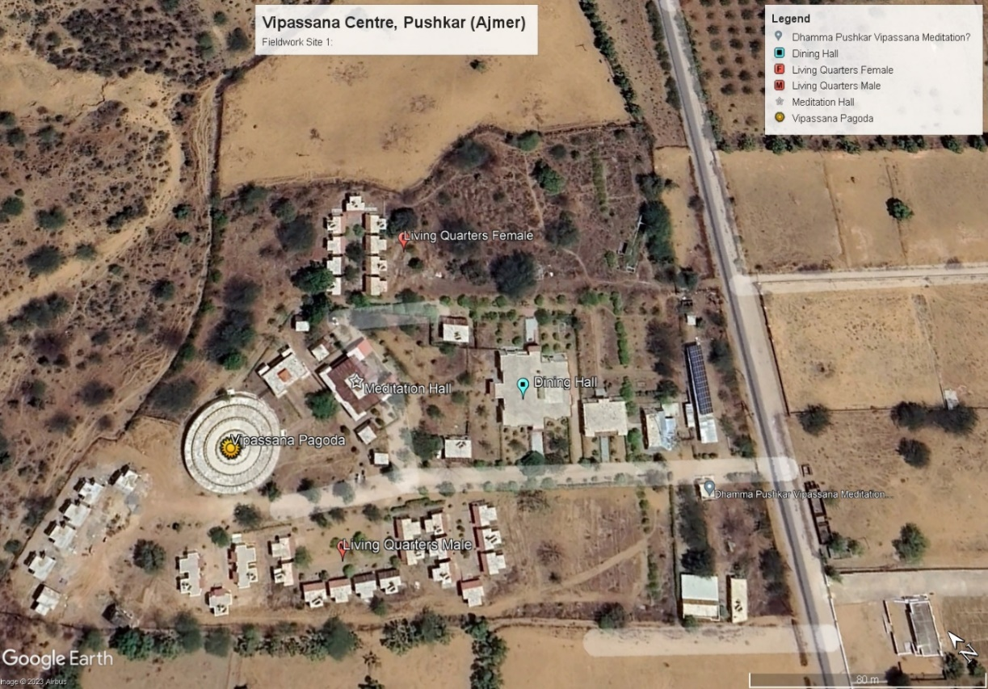

Figure 1:GIS layout of the field site created using Google Earth Pro

**4.1 Insights from Field site 1:**

Maintaining a 'noble silence' was a requirement from the very first day. This demonstrates a serious dedication to looking within and learning about oneself. It appears that certain people, perhaps those with more experience, were more in sync with the practices and ideals of Vipassana, as evidenced by the older gentleman who urged the others to observe stillness (Goenka, 2012).

Participation from a wide range of demographics, including students from top universities like IIM and working professionals, attests to the widespread interest in and utility of Vipassana. This demonstrates its promise as a cutting-edge "technology of the self" that tackles contemporary issues and stresses for a wide range of people.

Disciplined Habits: Participants are required to leave their cellphones in a secure location for the duration of the course and are awoken by a bell at a set time each morning, highlighting the course's emphasis on strict discipline and distancing participants from external distractions in order to foster in-depth reflection and active self-exploration (*SN Goenka’s Discourses*, n.d.) (Goenka, 2012).

Mental and physical struggles: Observations of individuals suffering from headaches, nausea, and vomiting attest to the strenuous nature of the training (*SN Goenka’s Discourses*, n.d.). As repressed memories and emotions are brought to the surface through the vipassana practice, the practitioner may experience significant bodily and emotional reactions (Carvalho, 2010).

Despite the fact that the meditation hall was shared, the sexes were kept apart as a sign of respect for personal space and limits. It's consistent with established cultural standards, too, so everyone can feel at ease and give their whole attention to the proceedings (Flood, 2019).

The phenomenon of voluntary attrition highlights the rigorous character of Vipassana and the diverse capacities of individuals to withstand or adjust to its requirements. The notion being addressed pertains to the concept of "agency" within the framework of individual metamorphosis (Flood, 2019). The personal nature of everyone’s journey is a fundamental aspect to consider (Goenka, 2012). Although Vipassana provides a structured framework, individuals must walk this route in a manner that is congruent with their own abilities and limits (“Stanford Encyclopaedia of Philosophy,” 2001). The aforementioned idea can be linked to Foucault's theoretical framework known as the "ethics of the self", wherein humans actively engage in self-directed actions and behaviours (*James, W. (2007). Vipassana Meditation and the Scientific Worldview. Contemporary Buddhism, 8(1), 83-102.*, n.d.).

Questioning the Conventions: The individual who defied the prevailing norms and exhibited a more casual or disrespectful demeanour towards the established course norms embodies a form of resistance or divergent understandings of the "technologies of the self". Although Vipassana offers a systematic approach to cultivating self-awareness, it is important to acknowledge that not all individuals may fully subscribe to or endorse its principles (Anderson, 2005). This aligns with the notion that individuals have the capacity to critically examine and engage with established societal norms, a topic that has been discussed by scholars such as Judith Butler in her examination of performativity and acts of resistance (*James, W. (2007). Vipassana Meditation and the Scientific Worldview. Contemporary Buddhism, 8(1), 83-102.*, n.d.) (Carvalho, 2010).

The Role of the Teacher: The teacher's intervention in reminding the individual about the principles of the course hints at the balance between individual freedom and adherence to the collective discipline. This might resonate with the "Guru-Shishya" (teacher-student) tradition in Indian philosophy, where the teacher's role isn't just to impart knowledge but to ensure that the learner is on the right path (*SN Goenka’s Discourses*, n.d.).

**4.2. Tilak Nagar, Jaipur**

Location: The one-day Vipassana courses in Jaipur are prominently conducted at the Tilak Nagar site. The specific address for this site is A-50/B, Chandrakala, 3rd floor (side gate), Shanti Path, near Birla Mandir Road.

Course Schedule: These courses occur every Sunday and span from 12 p.m. to 5 p.m.

Contact Information: For further queries or details, Mr. Dinesh Malpani can be reached at 9829165666.

Site Description: The meditation sessions are held on the top floor of an apartment building. This space, adapted for the purpose, offers a quiet and conducive environment for meditation. It is well-equipped with both air conditioning and fans to ensure the comfort of attendees. The guidance for the one-day course comes from a recorded discourse by S.N. Goenka, providing a structured and consistent experience for all participants.

 One noteworthy aspect of these sessions is the incorporation of silence as a prominent technique. It is mandatory for participants to observe silence throughout the entirety of the course, which serves to foster reflection and enhance concentration. At the midpoint of the event, a scheduled interval provides an opportunity for participants to replenish their sustenance. A selection of light snacks, comprising chai, biscuits, and a choice between upma and poha, is provided. Occasionally, the customary proceedings may be enhanced by the inclusion of a dessert, thereby fostering a collective sense of delight among the participants.

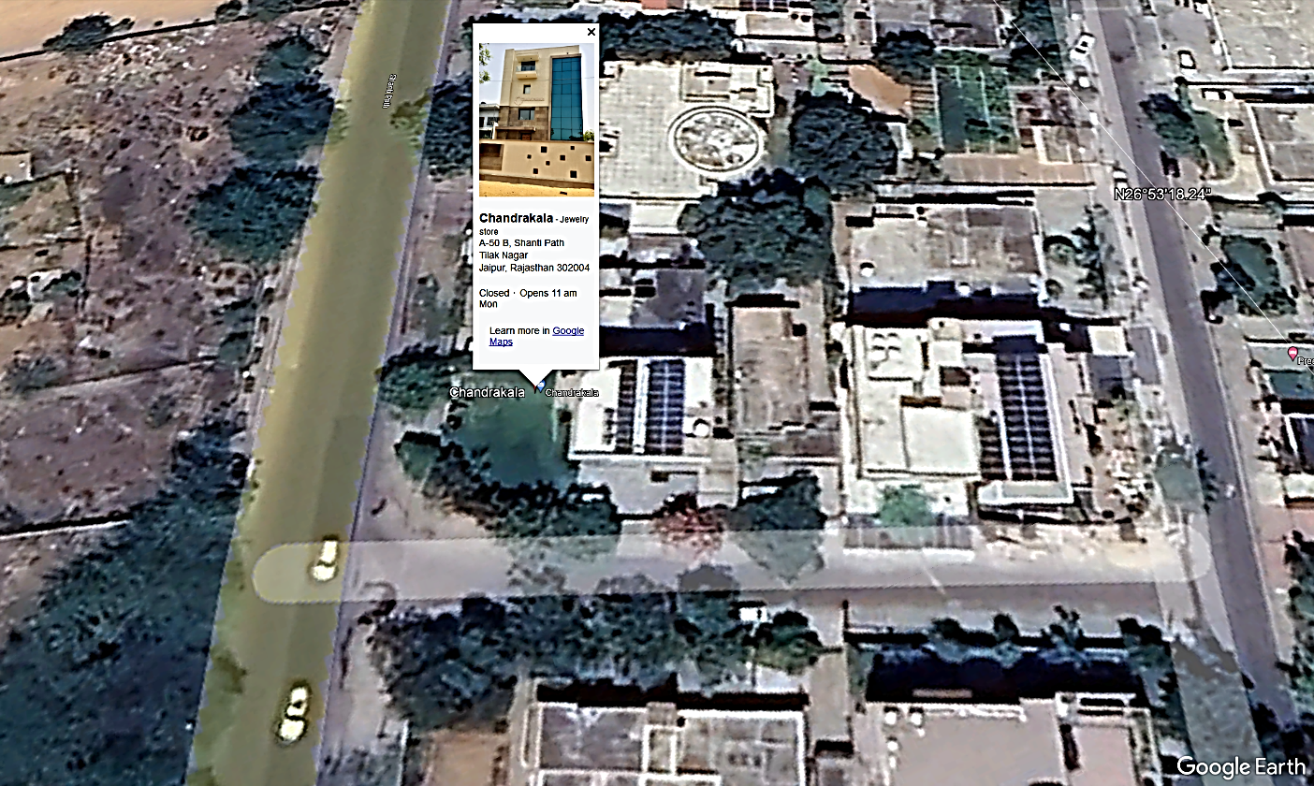

Figure 2:Chandrakala Building, One-Day Jaipur centre

**4.2 Insights from Field site 2:**

Adapted Spaces: The use of an apartment building's top floor for meditation emphasises the versatile nature of Vipassana practice. This illustrates how the practice integrates into urban lifestyles and doesn't exclusively rely on traditional or secluded spiritual spaces.

Using S.N. Goenka's taped lecture ensures that everyone, regardless of their prior experience with Vipassana or cultural background, receives the same level of guidance and instruction during meditation (*SN Goenka’s Discourses*, n.d.).

Structured Sociality: While Vipassana sessions demand silence, there are designated intervals, like shared mealtimes, which hint at a sense of limited community. Occasionally, someone will bring a dessert or snack, and it will be silently appreciated. This level of interaction, however, is limited (Flood, 2019). Participants in Vipassana aim to find a happy medium between strict adherence to rules and complete freedom to express themselves, and so they are welcome to come and go as they like, provided they do so silently (Anderson, 2005). During one event, I discretely helped an elderly guest by dropping her home after the session ended (Foucault, 1988).

The teachings and schedule of the Vipassana course have a clear structure, but they also allow for some flexibility. The core of discipline is shown through its adaptability to impromptu times that serve human connection and the simple joys of life (Carvalho, 2010).

1. **Data Reliability and Fieldwork Execution:**

**5.1 Methodologies: Tools and Techniques**

This study employed a multifaceted approach to data collection, ensuring a robust and reliable understanding of the Vipassana practice and its impacts. Each methodology was selected to capture both the subjective and communal aspects of the practice while maintaining rigor and depth in the data collected.

**5.1.1 Stages of Assessment:**

**Participant Observation:** The research began with direct engagement in Vipassana courses at various locations, including Pushkar, Ajmer, and Jaipur. These ranged from 1-day to 10-day courses. During this phase, detailed observations covered organizational and pedagogical aspects, as well as human dynamics, such as changes in behavior and group interactions. This foundational stage provided firsthand insights and established the base context for subsequent data collection methods.

**Interviews, FGDs, and Questionnaire Data Collection**: The core data collection involved a combination of semi-structured interviews, focused group discussions (FGDs), and questionnaires. In-depth interviews with 17 individuals (11 males and 6 females) were conducted using various modes, including face-to-face, telephonic, and video-call formats, to accommodate participant needs. Two FGD sessions were organized, focusing on themes such as empowerment, empathy, self-awareness, and the philosophical and scientific dimensions of Vipassana, offering communal perceptions and dynamics. Additionally, questionnaires were employed to capture socio-economic backgrounds and perceptual shifts in attributes like objectivity and empathy, enriching the overall data pool with diverse perspectives.

**Interview Transcription and Pre-Processing:** Following data collection, interview recordings were transcribed and subjected to initial natural language processing (NLP). This stage was critical for ensuring the accuracy and consistency of the data, preparing it for in-depth analysis while maintaining the integrity and depth of the information gathered (Fitkov-Norris and Kocheva).

**Database Design and Integration:** All collected data, including responses from questionnaires, interviews, and FGDs, were consolidated into a relational database using MySQL. This integration streamlined data management and retrieval, setting the stage for a comprehensive analysis. The use of advanced NLP techniques, including topic modeling with Python, in the previous analysis stage allowed for a nuanced exploration of emergent themes and patterns.

**Data Analysis and Contextual Analysis:** The final stage involved employing advanced NLP techniques to extract themes from the transcribed data, further enhanced by the insights gained from journal keeping and reflective notes. Despite the restrictive environment of Vipassana courses, discreet journaling provided a deeply personal and introspective layer to the data, adding richness and personal insights.

**Collection**

**Synthesis of Methodologies:** The study's methodological approach was characterized by its iterative nature, where each method built upon the previous, and the use of modern technologies not only streamlined the data analysis process but also uncovered deeper thematic insights. The diverse methodologies employed were instrumental in offering a holistic view of Vipassana practice, enhancing the robustness of the data and allowing for a nuanced exploration of themes and patterns that emerged**.B. Sampling Method:**

**Direct Contacts**: Initial contacts were established during my own 10-day Vipassana course. These participants provided insights that were directly connected to the researcher's personal Vipassana journey (Aycock, 2006).

**Word of Mouth and Referrals:** Subsequent participants were recruited through referrals from the initial contacts and through broader word-of-mouth efforts. This strategy was intended to access a more varied pool of respondents, even those who had not been directly encountered during the researcher's Vipassana course (*SN Goenka’s Discourses*, n.d.).

**5.2 Sampling Limitations:**

**Subjectivity:** The interpretive element of qualitative research is an inescapable reality. There will always be some degree of bias in the researcher's interpretation and presentation of participants' stories due to their own preconceptions and experiences (“The Sage Handbook of Qualitative Research,” 2009). The researcher's own life experiences will naturally become entangled with the group's narratives because of the researcher's involvement in Vipassana (Finlay, 2002).

**Generalizability**: The study may not be representative of the Vipassana community at large because of its small sample size and stringent inclusion criteria. As a result, not all Vipassana practitioners may benefit from the findings (Finlay, 2002).

Using people's recollections opens the door to the problem of recall bias. Their memories may be tainted or distorted by their current feelings, their current situation, or just the passage of time (Atsadonsak et al. 2681).

**Potential for Leading:** The semi-structured nature of the interviews, while allowing for organic dialogue, could also inadvertently steer respondents in certain directions based on the questions posed or the way they were presented. This can lead to a potential bias in the responses, as participants may feel compelled to provide answers that align with the interviewer's expectations or assumptions (“The Sage Handbook of Qualitative Research,” 2009). Additionally, the use of leading questions or subtle cues during the interview process may unintentionally influence the participants' perceptions or recollections, further compromising the validity of the data collected (Finlay, 2002).

**Geographical Skewness**: While there was some representation from other states, a substantial portion undertook the course in or around Jaipur, potentially introducing regional influences specific to this area.

**5.3 Adaptive Measures in Fieldwork:**

The process of fieldwork in this study was dynamic and responsive, evolving to capture the depth and diversity of experiences with Vipassana. As the interviews progressed, it became evident that a flexible approach was crucial to encourage rich, detailed responses and to respect the unique perspectives of each participant.

**Responsive Questioning and Enhanced Engagement**: Observing the varying degrees of responsiveness to different types of questions, I adapted my interviewing technique. For instance, participants like Jyoti, Sushila, Nandkishore, and Premchand, who had extensive experience with Vipassana, often emphasized its positive benefits. In these cases, to elicit more nuanced responses, I occasionally challenged their views or directed the conversation towards aspects they were more eager to discuss. This approach facilitated richer dialogues, revealing the multi-faceted impacts of Vipassana on individuals (Kempton 1).

**Refinement of Questioning for Depth and Relevance**: Initial interview questions included explicit inquiries about the social implications of practicing Vipassana, such as engagement in volunteer work. However, it became clear that Vipassana's impact was primarily introspective, influencing personal development and self-perception rather than directly prompting social service. This understanding led to a subtle yet significant shift in questioning. For example, while for Shveta, Vipassana was about solitary introspection, others viewed it as a tool for enhancing daily life interactions. This distinction underscored the need for implicit exploration of sociality within the practice.

**Cross-Validation and Looping Mechanism in Questioning**: To ensure comprehensive understanding and mitigate biases, the questioning technique incorporated a looping mechanism. This involved revisiting the core research questions through different angles and cross-validating responses. For participants like Himmat and Saideep, who were uncertain about Vipassana's role in their personal development, questions were reframed to explore changes in their interpersonal relationships post-Vipassana. Such a method ensured that each response not only contributed to the primary research inquiry but also resonated with the subtler themes emerging from the data (*The Sage Handbook* 249).

**Integration of Data into a Relational Database**: As the study progressed, the incorporation of a relational database emerged as a crucial tool. Initially not included in the research design, the database was developed to organize and analyze the rich data collected. Utilizing the Latent Dirichlet Allocation (LDA) model, provided deeper insights into thematic patterns and participant narratives, than simple open coding would have. This database was instrumental in visualizing connections and discrepancies among responses, further enhancing the study's analytical depth.

**Navigating Field Adaptability and Learning**: Navigating the field was an exercise in adaptability and questioning techniques. Unique cases, such as Saideep's mention of the One-World-Theory and Alind's neutral stance on Vipassana's benefits, highlighted the importance of flexible and open-ended questioning. This approach allowed for the accommodation of diverse perspectives, enriching the overall understanding of Vipassana's multifaceted impacts.

In conclusion, the adaptive measures employed during the fieldwork were fundamental in maintaining the integrity of the research. By ensuring that each adaptation looped back to the core research questions and by cross validating the emerging themes, the study upheld a rigorous and reflective investigative stance. This dynamic approach not only preserved the depth and reliability of the data but also illuminated the intricate layers of personal experiences with Vipassana.

**6. Data Processing Methodology**

The data processing phase of this study was a meticulous and multifaceted undertaking, essential for laying the groundwork for in-depth analysis. This phase encompassed transcription of interviews, application of natural language processing (NLP) techniques, and sophisticated machine learning models to distill and interpret the rich qualitative data collected.

**6.1 Transcription of Interviews:**

The transcription process was a blend of manual typing and automated transcription using Otter AI. For clarity and accuracy, interviews conducted in Hindi were carefully transcribed, with special attention to preserving the essence of the conversation during translation. Recognizing the potential loss of tone in textual format, side notes detailing the tone and nuances of each interview were meticulously made. This approach ensured that the transcriptions were not just literal representations of the spoken word but also captured the contextual and emotional subtleties inherent in each interaction.

* 1. **Natural Language Processing Techniques:**

Utilizing Python's Natural Language Toolkit (nltk), each of the 19 transcribed interviews underwent a detailed NLP analysis. This analysis involved tokenizing the text, identifying top words, and assessing sentiment polarity and subjectivity. Such a detailed linguistic examination provided a robust foundation for further in-depth analysis, allowing for the extraction of not only the thematic content of the interviews but also the underlying sentiments and perspectives of the participants. This granularity in data processing was crucial for a nuanced understanding of the subjective experiences shared during the interviews (Tang et al. Article 05001).

**6.3 Latent Dirichlet Allocation (LDA) Model:**

The LDA model, a form of machine learning algorithm within NLP, was employed via python to analyze the interview transcripts collectively. This model is adept at identifying latent topics within large volumes of text, making it particularly suited for thematic analysis in qualitative research. By processing the transcripts through the LDA model, distinct topics emerged that best encapsulated the textual data. These topics, such as "Awareness and Transformation" and "Debating the Essence of Vipassana," formed the crux of further discussion. The application of LDA also facilitated the assignment of weights to each respondent's dominant topic, enabling a quantifiable link between individual narratives and overarching themes (Tang et al. Article 05001).

**6.4 Named Entity Recognition (NER):**

NER was utilized to extract specific types of entities (essentially words) from the transcripts, into Systems,Date-Time, People, Quantity, Spatial Identity, and Hierarchy. This technique allowed for the identification and frequency analysis of these entities, providing insights into the contextual elements of the interviews. For example, the extraction of ‘People’ entities highlighted key individuals referenced in the narratives, while 'Spatial Identity or Geopolitical Entities' entities shed light on geographical influences within the respondents' stories. Such detailed entity analysis was invaluable in identifying the subtle nuances and contextual layers embedded within the interviews, further enriching the qualitative data analysis.

6.5 A Technical Look:

Initially, with a Python script, I collated the text files containing transcribed interviews. Preprocessing included a meticulous cleaning phase where non-contributory elements like interviewer tags and common respondent names were removed, ensuring a focus on content-rich data. Tokenization was then executed to segment the text into manageable units for analysis, further refined by excluding stop words and implementing stemming to consolidate word variations.

For sentiment analysis, a library like TextBlob was used to calculate sentiment polarity (positive or negative) and subjectivity scores, providing a quantitative measure of the emotions and opinions expressed. Noun phrase extraction offered a concentrated view of key themes within the text.

I then constructed a dictionary from the tokenized text, which facilitated a conversion of text into a numerical form suitable for machine learning via the Bag-of-Words model. The LDA model was finely tuned with numerous passes and auto adjusted hyperparameters to ensure a robust thematic extraction.

The coherence of topics generated by the LDA model was quantitatively assessed, ensuring the relevance and distinctiveness of each topic. Lastly, an analysis for each document determined the dominant topic and its associated word-weight pairs, which were methodically cataloged, illustrating the prevalence and significance of each theme across the dataset.

In conclusion, the data processing phase was characterized by a blend of manual diligence and sophisticated analytical techniques. The meticulous transcription process, combined with advanced NLP and machine learning applications, set a solid foundation for a comprehensive and nuanced exploration of the collected qualitative data. This phase was instrumental in transitioning from raw interview transcripts to analyzable data, paving the way for the thematic and contextual analyses that form the essence of the subsequent chapters.

**7. Relational Database Design**

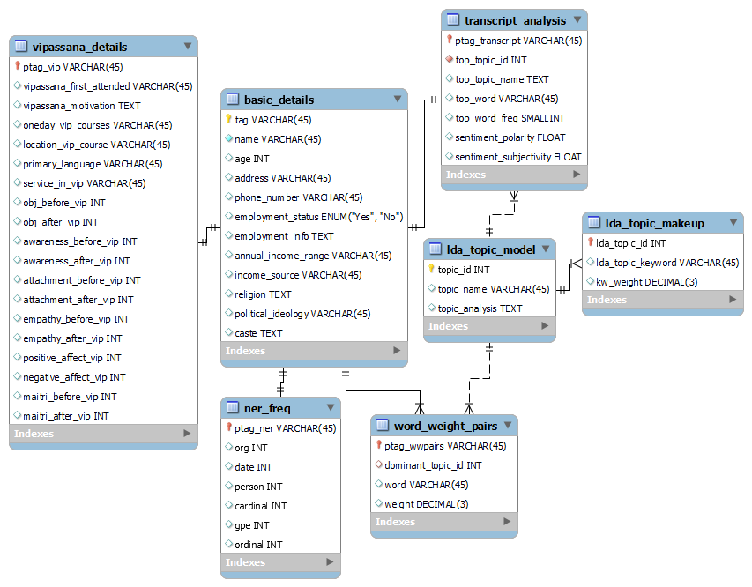

Figure 3: Vipassana Thesis: Relational Database Design on MYSQL

The relational database design presented in the image showcases a structured approach to organizing and analyzing the qualitative data from Vipassana meditation research. The design includes several interlinked tables, each serving a distinct role in the representation of the data:

vipassana_details: Contains fields related to the individual experiences and background information of the participants, such as their first attendance, motivational factors, and changes in various psychological states pre- and post-Vipassana.

basic_details: Records demographic and personal information, providing context and background for each participant, which could be used for correlating with meditation experiences.

transcript_analysis: Stores analytical data derived from the transcripts, including topic modeling and sentiment analysis metrics, linking back to the participants through a tagging system.

lda_topic_model: Holds the results of the Latent Dirichlet Allocation (LDA) analysis, indicating the various topics discovered within the transcripts and their respective weightings.

lda_topic_makeup: Holds the keywords and their respective weights associated with each topic of the lda model. Essentially, a set of keywords which comprise a topic.

ner_freq: Relates to the Named Entity Recognition (NER) process, cataloging the frequency of various entities mentioned in the conversations, such as organizations, dates, or persons.

word_weight_pairs: This table stores specific words and their associated weights (importance) within the context of the discussions, which can be tied back to the dominant topics from the LDA analysis.

Overall, this EER model efficiently categorizes and relates different dimensions of the research data, from personal background to in-depth analysis of textual data. The database design facilitates a comprehensive study of the effects of Vipassana meditation on individuals.

Chapter 3: Data Analysis and Interpretation

1. Introduction

As we pivot from the methodological framework established in Chapter 2 to the empirical exploration in Chapter 3, we delve into the heart of our research—data analysis. This chapter will unfold in layers, starting with organic queries that allow the data to speak for itself, thus ensuring an emergent analysis that is grounded in the actual experiences and words of the participants. We will then align these emergent themes with our research questions to ensure that our analysis remains tethered to the core objectives of our study.

As an illustrative example consider a query that examines the change in participants' awareness due to their Vipassana meditation experience. This query selects the top five participants who have experienced the greatest self-reported change in self-awareness, alongside their initial motivations for attending a Vipassana course. The sentiment polarity (range from -1 to 1) column is included to provide insight into the emotional tone of participants' experiences as reflected in their interview transcripts. By examining these elements together, we can begin to understand not just the magnitude of change, but also the personal drivers behind the participants' journeys and how they may relate to their experiences as reported in the interviews.

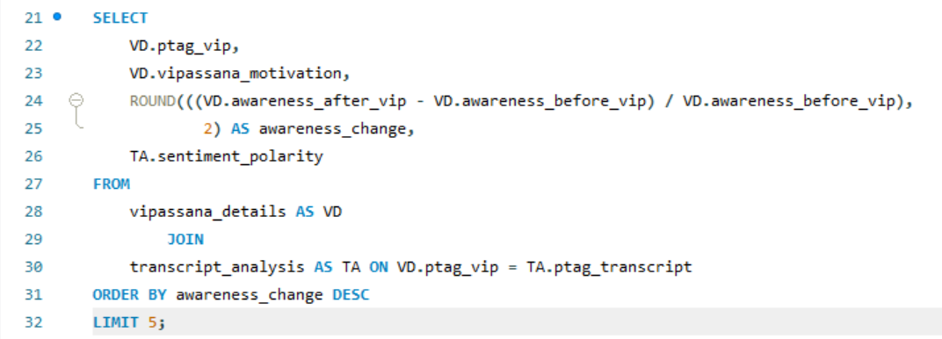

Figure 1: MYSQL query screenshot

Note: The following above is only for illustrative purposes; for further analysis and queries, the actual query will be provided in a separate file, and only the rationale and tabular data will be displayed here. We get the following results:

|  |  |  |  |
| --- | --- | --- | --- |
| **ptag_vip** | **vipassana_motivation** | **awareness_change** | **sentiment_polarity** |
| anirudh | To understand the technique to self-reflect | 4 | 0.157036 |
| premchand | Family | 4 | 0.12625 |
| alind | To see things more objectively and to improve focus | 3 | 0.148782 |
| sandhya | To practice silence and be with self to learn meditation | 2 | 0.222071 |
| jyoti | Inclination towards Sadhna and wanted to learn more | 1.5 | 0.0831362 |

Table 1: Top 5 respondents with most awareness change and their motivations

Upon executing such a query, I may choose to present the data in a table format or a graph to give an overview of the sentiments associated with this theme (like above). Following this, a detailed analysis will be conducted, weaving in direct quotations from the transcripts to enrich our understanding of the topic. This approach allows me to maintain a balance between quantitative data representation and qualitative narrative depth.

Each section of this chapter will follow a similar structure:

Present the Query: Describe the rationale behind the query and what we aim to uncover.

Display the Table: Consider including the table if it succinctly summarizes the data and aids in understanding.

Analyze and Interpret: Go beyond the numbers to explore what these findings tell us about the broader narratives at play.

In doing so, we not only honor the voices of our participants but also construct a bridge to the theoretical discussions in subsequent chapters, thus ensuring a cohesive and comprehensive thesis narrative.

**2. Understanding the Social Location and Vipassana details of respondents:**

2.1 In the quest to deepen our comprehension of the transformative journey through Vipassana meditation, it becomes pivotal to contextualize the experiences within the framework of each individual's social location. This section, "Understanding the Social Location and Vipassana Details of Respondents," aims to illuminate the intricate tapestry of personal motivations, frequency of practice, and the socio-economic backdrops that shape the participants' engagement with Vipassana (*Stanford Encyclopedia of Philosophy* 9).

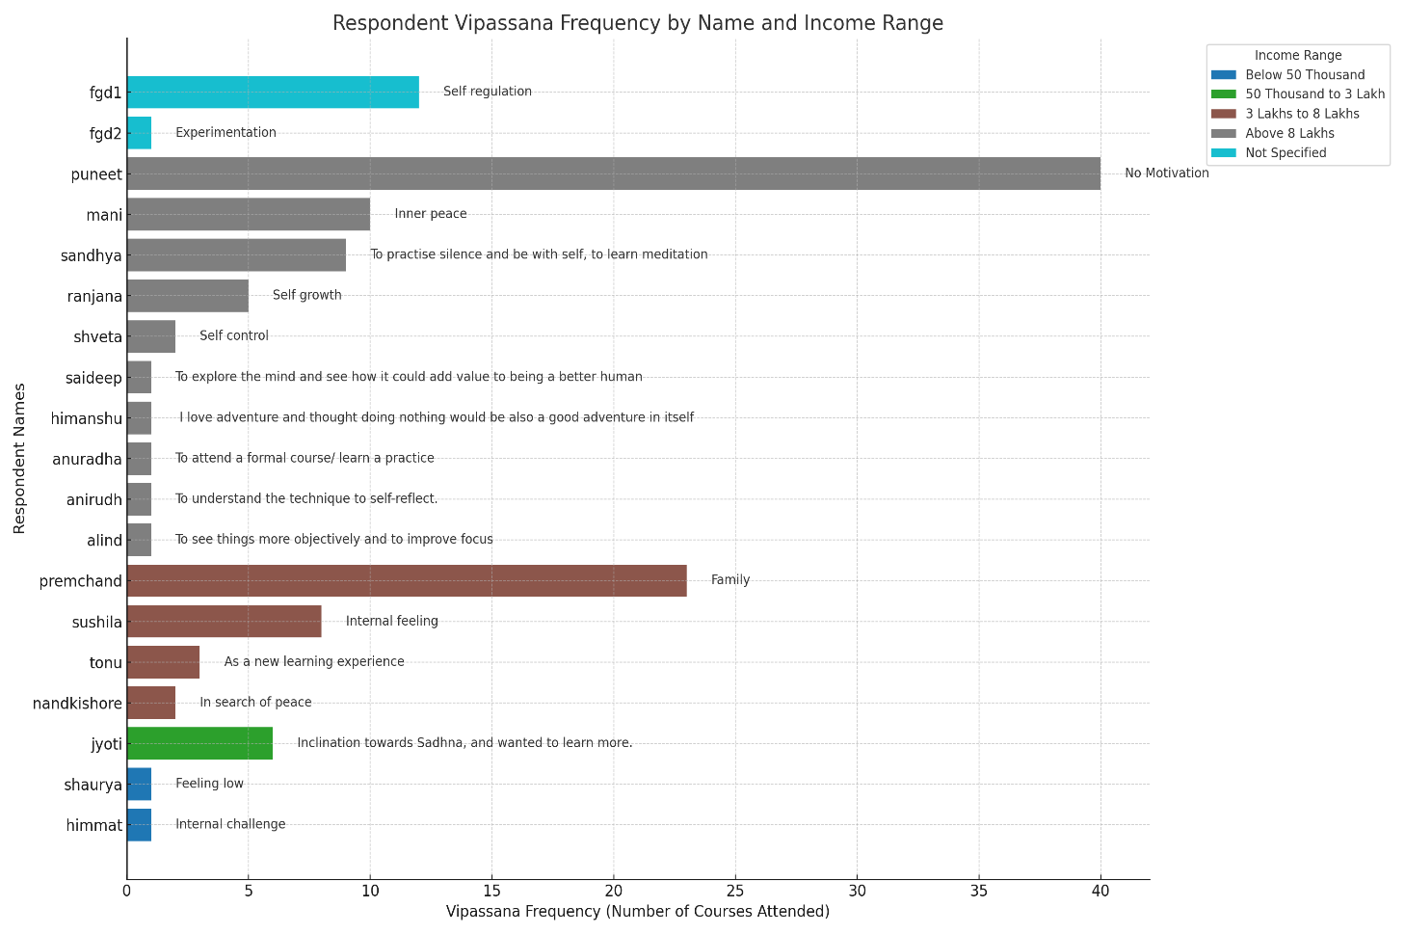

Figure 2: Number of Vipassana Courses, Income Range, and Initial Motivations for each Individual

**2.2 The graph below, titled** "**Figure 3: Respondent Age Distribution & Employment Info by Location of Vipassana Course Attended**" provides a layered overview of the individuals participating in Vipassana meditation courses. It maps out the age range of respondents against the locations where they've attended these courses, distinguishing between those currently employed (marked in blue) and those not in the workforce (indicated in red, which includes retirees, homemakers, and students). Each point is annotated with the respondent's profession, offering a glimpse into the professional diversity within the Vipassana community. This chart, when synthesized with previous data showing the frequency of course attendance and the socioeconomic status of the respondents, affords a richer, more nuanced understanding of the demographic engaging with Vipassana.

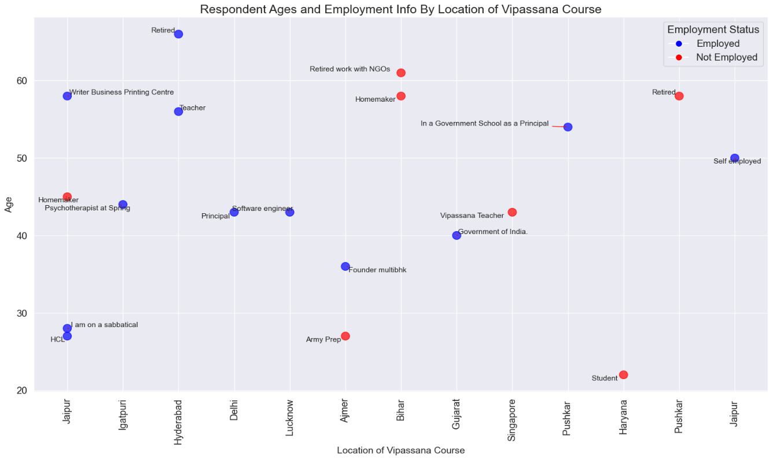

Figure 3: Respondent Age Distribution & Employment Info by Location of Vipassana Course Attended

**2.3 Insights on Social Location from Both Figures:**

**Demographic Diversity**: Both graphs demonstrate a broad demographic diversity among the respondents. The first graph shows a range of income levels, while the second graph shows varied ages and employment statuses. Together, they suggest that Vipassana meditation appeals across a wide spectrum of social, economic, and age groups and income does not seem to play a major role for such a practice.

**Motivation and Life Stages**: The first graph outlines motivations for practicing Vipassana, while the second provides context about the respondents' life stages and careers. For example, younger individuals might be seeking Vipassana for growth or learning, while those who are retired may seek peace or a meaningful way to spend their time. **Geographic and Socio-Economic Patterns**: The first graph does not specify geographic information, but the second graph adds this layer, showing where the respondents attended the Vipassana course.. For example, certain language barriers or cultural contexts might lead one to have a different experience of Vipassana than others in the same place.

**Employment Status and Engagement: The second graph depicts employment status, which, when combined with the frequency of course attendance from the first graph, may indicate how individuals with varying work commitments can engage with Vipassana practises. For example, those who are not employed may have more time to attend frequent courses.**

**Holistic Understanding of Respondents**: By combining the insights from both graphs, we can build a comprehensive profile of the respondents. We see not only their economic and motivational backgrounds but also their age, employment status, and locations of practice. This multi-dimensional view helps in understanding the diverse appeal and impact of Vipassana on individuals from various walks of life.

**3. Emergence & Interpretation of Organic Topics:**

Topic Modelling: The topics outlined here were not pre-defined; instead, they naturally emerged from the aggregation of weighted keywords, illustrating the spontaneous structure of themes within the conversations about Vipassana.

|  |  |  |
| --- | --- | --- |
| **topic_name** | **keywords** | **topic_analysis** |
| Awareness and Transformation | practice, not, life, understanding, sense, think, self, change, might, others | This topic appears to focus on the journey of self-awareness and potential transformation through Vipassana. It covers aspects of personal conflict and growth |
| Debating the essence of Vipassana | know, not, think, people, feel, one, say, something, right, now | Dominated by words like 'know,''not,'' and 'think,'' this topic seems to represent a space of critical reflection and discourse. It suggests discussions where ideas, beliefs, and feelings about Vipassana are questioned, debated, and reflected upon, possibly indicating diverse and contrasting opinions |
| Integrative life perspectives | life, personal, experience, practice, however, not, understanding, societal, issues, think | This topic encapsulates a holistic view of Vipassana, intertwining personal experiences and societal perspectives. It covers a broad range of elements from personal practice to societal issues, reflecting on the complexities and diverse interpretations of Vipassana in life. The presence of 'not' and 'however' suggests a nuanced or possibly critical exploration of these aspects |
| Philosophical underpinnings | meditation, practice, nature, understanding, often, approach, personal, experience, life, law | This topic is likely centered around the meditation practice itself, including its nature and various philosophical understandings. It might discuss the regularity ('often'), principles ('law'), and different approaches to meditation, emphasizing how these aspects are woven into personal life and experiences |

Table 2: Topics, Keyword-Topic Makeup & Brief Description

The analysis of these topics offers a panoramic view of the collective consciousness of Vipassana practitioners. Each topic provides a window into the participants' introspections and societal reflections, which are crucial for understanding the personal and communal aspects of meditation practice. The 'Awareness and Transformation' topic, for instance, underscores the transformative power of Vipassana in cultivating self-awareness and personal growth (Goenka). In contrast, 'Debating the Essence of Vipassana' highlights the intellectual engagement of practitioners as they critically navigate through the tenets of the practice. The 'Integrative Life Perspectives' topic illustrates how Vipassana is perceived and practiced within the larger framework of personal and societal life, hinting at the complexities and diverse interpretations that individuals bring to their practice. Lastly, the 'Philosophical Underpinnings' topic suggests a deep engagement with the theoretical and philosophical aspects of meditation, reflecting on how these principles integrate into the fabric of daily life (*Stanford Encyclopedia of Philosophy* 9).

**3.1 Participant Distribution & Average Sentiment Analysis across Topics:**

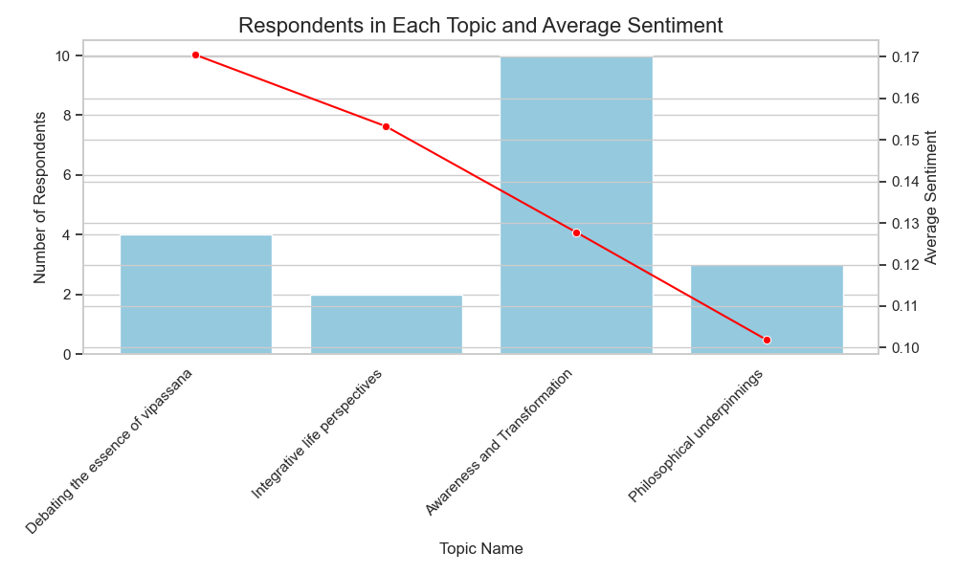

Figure 4:Count of Respondents and Average Sentiment by Topic

We could then extend the above analysis to determine the average sentiment and number of respondents for each topic (Erniyati et al.).

*Note: This is possible because, in addition to the four main topics, I have the dominant topic that emerged from each interview transcript (falling under one of the four topics). The graph does not imply that one interview transcript is limited to a single topic, but rather that that topic is the dominant topic for that transcript.*

The provided visualization offers a composite snapshot of the prevailing discourse themes among Vipassana adherents, as discerned through a sophisticated LDA topic modeling method. This chart is pivotal because it showcases not only the engagement level across diverse topics but also juxtaposes this data with the prevailing sentiment tied to each thematic discussion. This dual-perspective presentation has been deliberately chosen to underscore the breadth and depth of the dialogues and to shed light on the emotional resonance these topics hold within the practitioner community (Goenka).

Topping the chart is the 'Awareness and Transformation' topic, commanding the largest participant cohort. This mirrors the significant weight the Vipassana tradition accords to the facets of self-awareness and evolutionary growth. The considerable draw to this theme intimates a collective prioritization of introspective dialogue concerning transformative personal experiences—a sentiment echoed by Anirudh Narula, who sees Vipassana as a "guiding framework for self-awareness and personal growth." (Rahmani)

In stark contrast, 'Integrative Life Perspectives' seems to attract a smaller, though no less engaged, segment of practitioners. This topic, though lesser in participant volume, harbors a sentiment score not far adrift from the 'Debating the Essence of Vipassana' theme. It points to a dedicated contingent of practitioners like Anuradha, who perceives the journey of seeking self-knowledge as ever evolving, expressing, "I might ask myself who am I? I see that seeking is that journey." This group appears to weave Vipassana seamlessly into the tapestry of their daily lives, denoting a profound integration of meditative principles with personal and societal dynamics (Erniyati et al.).

The moderate engagement seen in 'Debating the Essence of Vipassana' and 'Philosophical Underpinnings' suggests a balanced intellectual and contemplative engagement within the community. The former reflects a dynamic examination of Vipassana's foundational principles, hinting at an active intellectual community willing to scrutinize and evolve its understanding of the practice (Chamaiah Swamy et al.). Puneet's reflection provides a critical counterpoint here: "There's often a subtle pressure to conform to its doctrines without question," suggesting a dialectic between personal understanding and communal doctrine. Meanwhile, the latter topic's traction points to a thorough exploration of Vipassana within the realms of philosophical thought and existential inquiry, indicating a community that values deep theoretical engagement as a complement to practical application (Mani and Mishra).

It is reasonable to assume that the practitioners' varied interests in particular areas reflect the wide range of experiences they have had with the Vipassana tradition. Although 'Awareness and Transformation' is a fundamental part of the community story, showing that everyone wants to improve themselves and learn more about themselves, the varied average feelings show that every subject has complex emotional undertones (Kempton 1). These scores reflect the diverse experiences and emotional valence of the practitioners' dialogues, providing a subtle barometer of the collective affect.

**3.2 Self-Reported Scores before and after Vipassana:**

The radar chart, which displays average self-reported scores before and after Vipassana meditation across various personal attributes, provides intriguing insights that tangentially complement the findings from the LDA model analysis of raw transcript data. This juxtaposition of quantitative self-perception metrics with qualitative thematic content from practitioner dialogues offer a multi-faceted view into the complex tapestry of Vipassana's impact (Kempton 1).

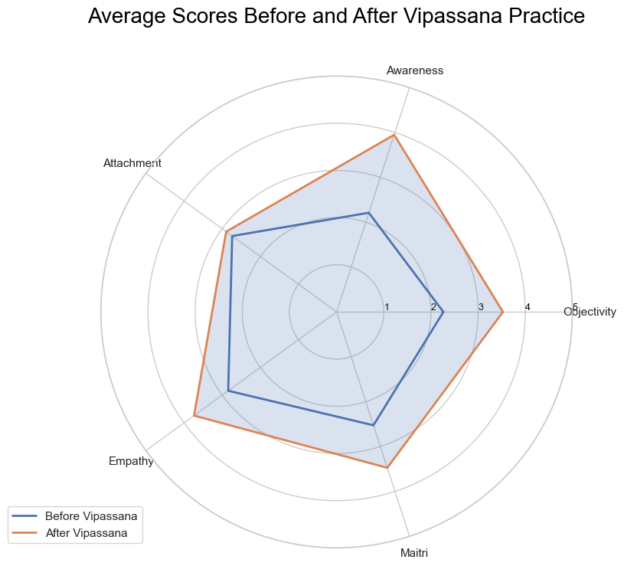

Figure5: Avg (self-reported) scores before and after Vipassana

**3.2.1 Key Observations from the Radar Chart:**

**Awareness and Empathy**: Notably, there's a marked increase in scores for 'Awareness' and 'Empathy' post-Vipassana (Emavardhana and Tori 194). This aligns with the LDA topic 'Awareness and Transformation', underlining the transformative aspect of Vipassana in enhancing self-awareness and empathy. While this does not conclusively denote a positive transformation, it indicates a shift in the practitioners' self-perception in these areas, resonating with the primary objective of exploring self-to-self and self-to-other transformations.

**Attachment and Objectivity**: The scores show a moderate increase in 'Attachment' and a more substantial increase in 'Objectivity'. This suggests a nuanced shift in relational dynamics and individual self-perception. The increase in objectivity may reflect a deeper engagement with Foucault’s conceptual frameworks of “care of the self” and “knowing oneself,” implicating a more reflective and discerning approach to personal and interpersonal understanding (Emavardhana and Tori 194).

**Maitri (Universal Love)**: The increase in 'Maitri' scores post-Vipassana meditation touches upon the sub-objective of reconciling the teachings of Vipassana, especially 'Maitri', with their actual expressions in contemporary societal dynamics. This increment, though self-reported, hints at a potential enhancement in the feeling of universal love and compassion among practitioners (Chamaiah Swamy et al.).

**3.2.2 Interpreting the Data in Context:**

While the data presents an upward trend in certain attributes post-Vipassana, it's important to approach these findings with a critical lens. The self-reported nature of the data necessitates a cautious interpretation, especially in the absence of corroborating objective measures. The findings should be viewed as indicative rather than definitive, contributing to the broader exploration of Vipassana’s influence on the self (Mani and Mishra).

Positioning Vipassana in the Modern World:

The reported changes post-Vipassana also contribute to the objective of positioning Vipassana in addressing modern challenges like mental wellness and social division. The increases in empathy and awareness, for instance, may suggest beneficial outcomes in terms of mental health and social harmony (Emavardhana and Tori 194).

In conclusion, while the radar chart data provides valuable insights, it should be interpreted as one piece of a larger puzzle. It serves to enrich the qualitative findings from the LDA model, offering a complementary perspective that underscores the multifaceted impact of Vipassana meditation practice. This multimodal approach, blending personal experiences with academic inquiry, enhances the depth and nuance of the study, contributing significantly to the understanding of Vipassana's role in the contemporary context (Kempton 1).

4. **Recognizing Named Entities**

Names Entities helps identify and categorize key information from unstructured text, which is valuable in qualitative research. By extracting entities such as organizations, dates, persons, geopolitical entities, and numerical data, we can analyze the frequency and context of these references in the interviews A brief explanation of the entities is provided below:

* + Systems: This entity focuses on words used by the individual regarding rules and structures and the relative importance of each.
  + Date_Time: This entity focuses on words used by the individuals that showcase passing of time and importance given to the past, present, and future.
  + People: This entity focuses on words used by the individual to describe persons – could be related to closeness, attachment, love, self-etc.
  + Spatial Identity: This entity focuses on words used by the individual to describe their sense of identity as tied to specific geographic locations.
  + Quantity: This entity focuses on words used by the individual to describe how much they focus on tangible measurable things.

Figure 5: Named Entities and Frequencies from all interview transcripts combined.

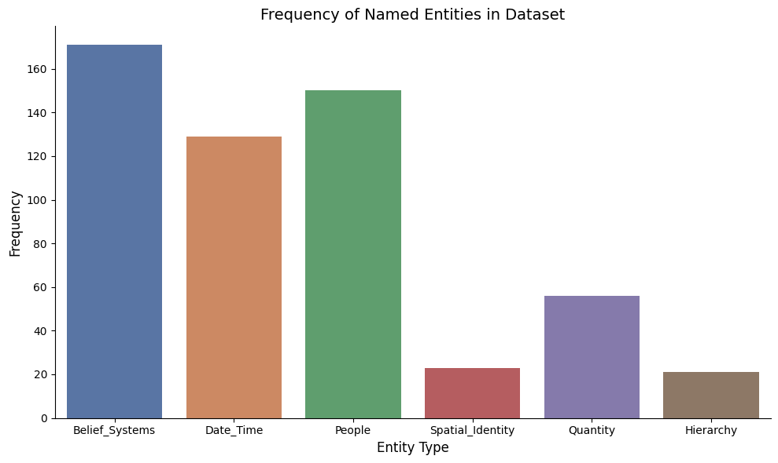

* + Hierarchy: This entity focuses on words used by an individual to describe their focus on rankings in aspects of their daily lives (more than, less than etc.).

The bar graph above indicates the relative frequency of different types of named entities. This quantitative analysis complements the qualitative depth of allowing me to discern patterns such as which entities are most discussed. For instance, a high frequency of 'person' entities might indicate the importance of personal relationships or individual figures in the practice of Vipassana (Mani and Mishra) .

* 1. **Topics and Named Entities Heatmap (Distribution by word-weights):**

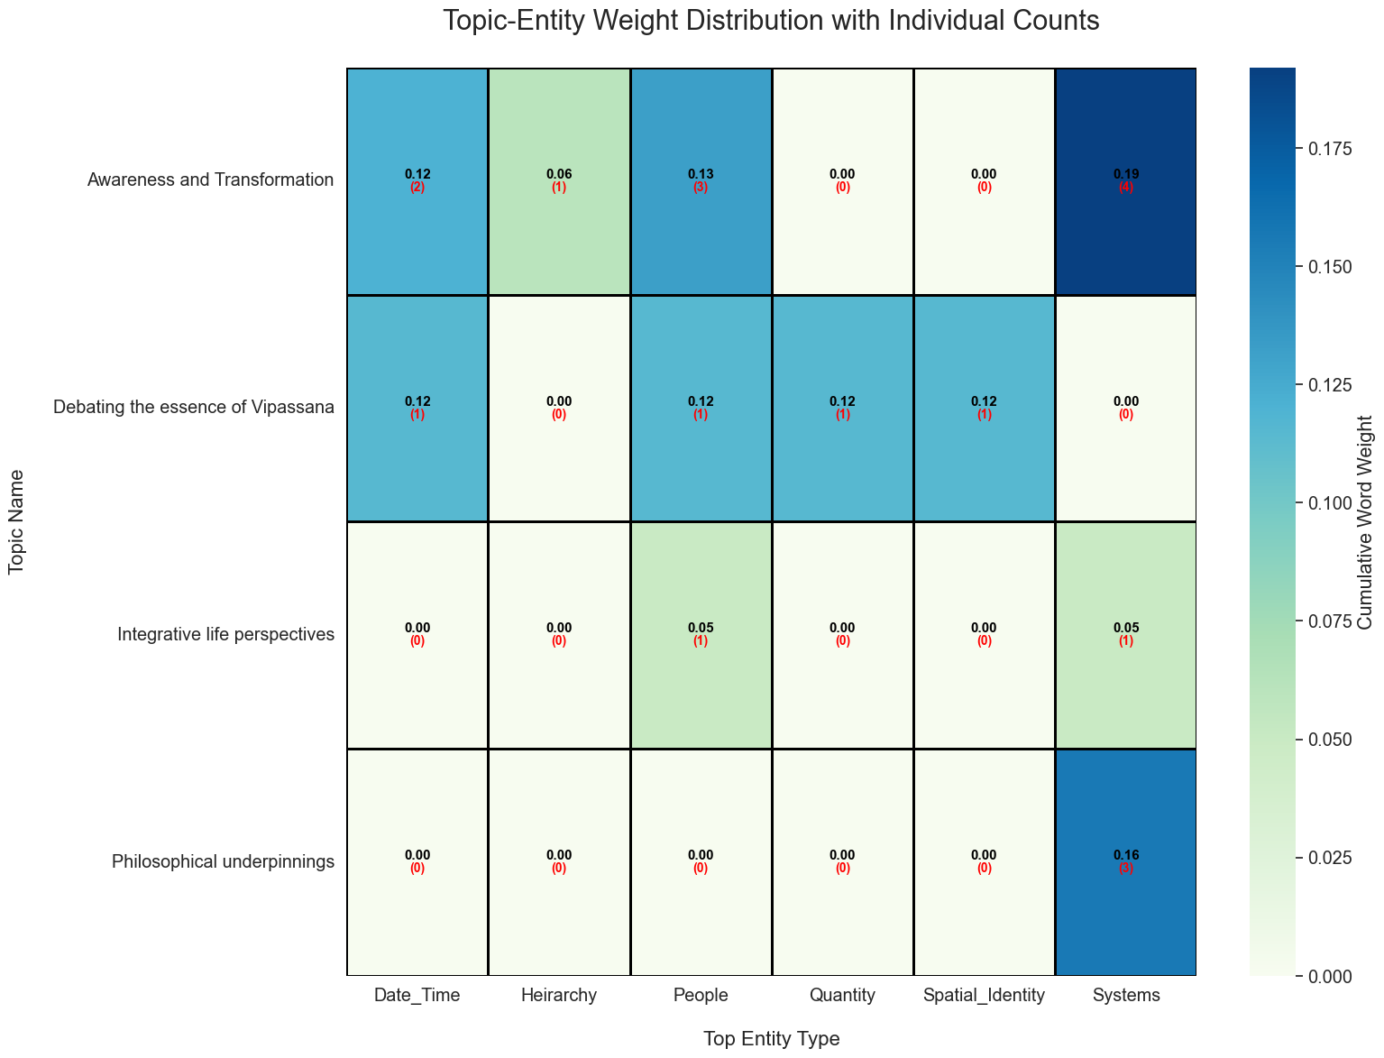

Figure 6: Topics & Named Entities (Distribution by word-weights)

Following the examination of Named Entity Recognition (NER) in our dataset, which provided a quantitative breakdown of entity types discussed in the interviews, we now turn to the Topic-Entity Weight and Count Distribution Heatmap. This visualization takes our analysis a step further by correlating the weight and frequency of specific words with the identified entity types within the context of each LDA-derived topic.

The heatmap enriches our understanding of how different types of entities are not only present but also emphasized in the discourse on Vipassana. It allows us to see which entities are most associated with topics and to what degree. By examining both the weight, indicative of a word's relative importance within the topic, and the count in the bracket, reflective of the number of individuals contributing to these discussions, we gain a multifaceted view of the thematic structure of our interviews (Kempton 1).

**4.1.1** **Insights from Topic-Entity Weight Distribution Plot:**

If we look at Jyoti's narrative in the context of the above figure, we see a significant personal transformation through the practice of Vipassana, where she mentions gaining 'heightened awareness' and a 'deepening of empathy'. Her statements reflect a shift from self-critique to a broader perspective of understanding and service towards others. This aligns with the topic 'Awareness and Transformation', which is weighted towards ‘Systems’. It suggests that Jyoti's transformation is not only internal but also oriented towards her societal role and contributions (Rahmani) .

Her reference to 'Maitri' and 'Karuna' indicates a personal journey of cultivating inner qualities that have societal implications, which ties back to the heatmap where ‘Systems’ is a top entity, indicating a collective or structured aspect of transformation.

The data and Jyoti's experiences suggest that 'Awareness and Transformation' within the context of Vipassana is not only about personal change but also about how these changes influence one's interaction with the wider community and societal structures, here represented by ‘Systems’.

Based on Mani's transcript and her association with the 'Awareness and Transformation' topic, we can deduce that her experiences and beliefs are deeply personal. She expresses that Vipassana meditation has led to a significant reduction in stress and has provided her with a more equanimous approach to life's challenges, including the handling of her mother's passing (Chamaiah Swamy et al.) . Mani's dedication to the practice is reflected in her daily meditation routine and her belief in its efficacy for physical ailments like back pain.

Her perspective is unique in that she emphasizes the 'practice' rather than the philosophy, indicating a personal, experiential relationship with Vipassana. Her narrative reinforces the ‘People’ entity types as central in her discussions, highlighting the individual practice the personal journey one undergoes through Vipassana, which might be a testament to the transformative power of the practice on a personal level.

Mani's transcript shows a blend of practical application and a profound, almost reverential belief in Vipassana's role in her life. It reveals how individual stories contribute to the larger thematic structure of interviews on Vipassana and its impact on personal transformation (Chamaiah Swamy et al.) . This case particularly exemplifies the weight distribution towards ‘People’ in the heatmap, where individual narratives underscore personal transformation and awareness . (Rahmani)

For example, in the interview with Himmat, personal relationships and individual figures play a significant role, evidenced by his mention of a "I felt closer to nature post-vipassana, but I like this girl, who is fond of nature, and " This personal anecdote falls under the ‘People’ category and indicates how individual relationships can influence one's connection to nature and, indirectly, their spiritual practices like Vipassana (Emavardhana and Tori 194) . Additionally, Himmat references his parents, categorizing them as 'persons,' which further highlights the impact of familial relationships on his spiritual journey. Such mentions provide insights into the social and interpersonal dimensions of spiritual practice.

In Ranjana's transcript, the prominence of ‘Date_Time’ as the top entity type signals a strong connection to specific times which mark her Vipassana journey, underscoring the significance of particular moments or periods in her transformative process. Her mentions of attending a session in "November 2022" indicate the importance she places on the temporal milestones of her practice, suggesting a chronological narrative of growth and change (Atsadonsak et al. 2681).

Ranjana's emphasis on Vipassana's scientific and moral grounding and her daily meditation practice exemplify her dedicated approach to transformation (Carvalho 7). This ties back to the 'Awareness and Transformation' topic in the heatmap, where the frequency of ‘Date_Time’ suggests a narrative interwoven with temporal references, perhaps framing transformation as a journey with distinct phases or events.

In Shaurya's interview, we can draw connections between the themes identified through LDA topic modeling and the specific entities revealed by NER. Shaurya's journey to Vipassana, influenced by his academic interest in Buddha and Ambedkar and his father's IPS career, highlights the entities ‘People’ (Buddha, Ambedkar, father) and ‘Systems’ (law school, public service). His aspiration to develop mental discipline and resilience for a career in law and public service aligns with the themes of personal growth and societal contribution identified in LDA as “Integrative Life Perspective” (Atsadonsak et al. 2681).

Shaurya discusses the practical exploration of empathy, justice, and self-awareness principles learned theoretically, which LDA could classify under themes related to spiritual practice and ethical living. His struggle to integrate Vipassana's introspective nature into the dynamic world of law and public service reflects the conflict between personal spiritual practices and professional demands, another theme of “Debating the essence of Vipassana” from the topics ("Self-Knowledge").

**4.2 Deepening the Analysis: From NER and LDA to Top word & Sentiment Subjectivity:**

Following the foundational analysis through Named Entity Recognition (NER) and Latent Dirichlet Allocation (LDA) topic modeling, we expand our exploration to include sentiment subjectivity associated with the top words used by Vipassana participants. This advanced analysis leverages sentiment analysis techniques to understand the emotional depth behind the words, providing a nuanced view of individual experiences and perceptions.

Sentiment analysis, a cornerstone of computational linguistics (Fitkov-Norris and Kocheva), evaluates the sentiment subjectivity and polarity within text data, revealing the emotional undertones of language used by individuals. By applying this to the words most frequently mentioned in interviews, we gain insights into how participants feel about their experiences and the concepts most important to them.

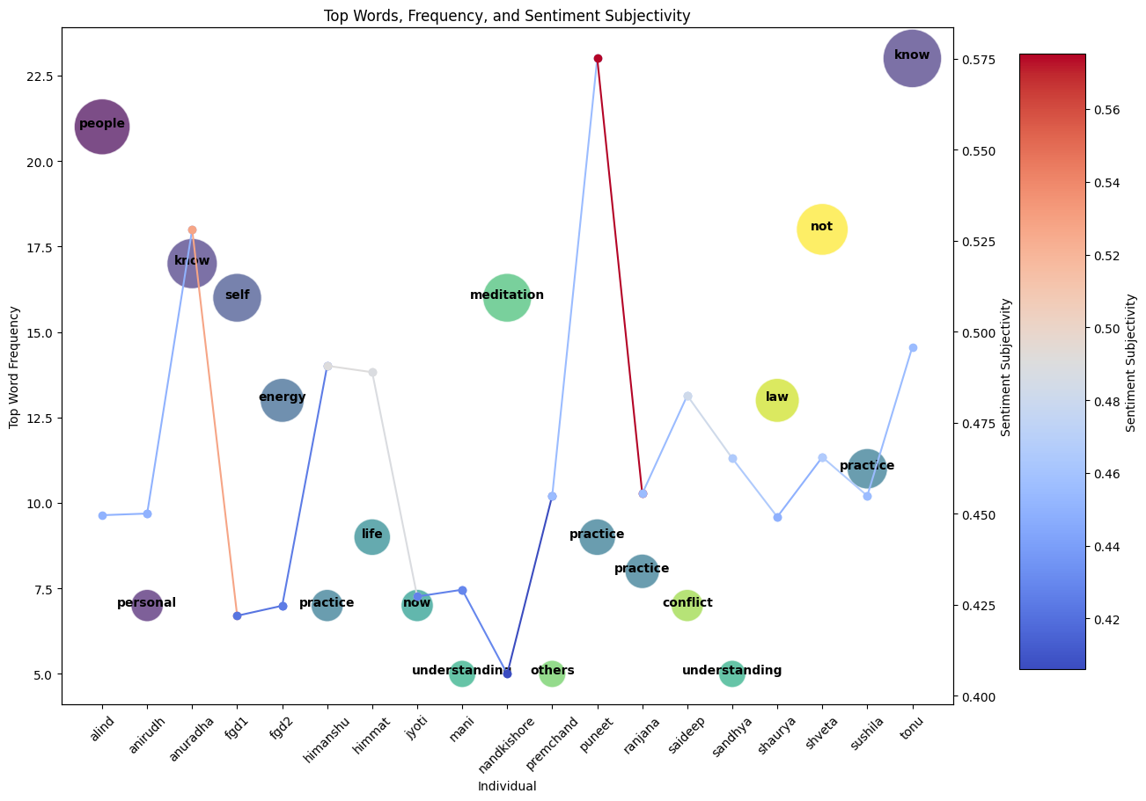

Figure 8: Top Word & Sentiment Subjectivity of each Individual

The transition from NER and LDA to sentiment subjectivity and top word allows us to connect specific entities and themes with the emotional resonance they carry for individuals.

An illustrative example from the discussions in fgd1 shows "self" as a top word, accompanied by a high sentiment subjectivity score. This suggests a profound engagement with and reflection on one's identity and role within the community, indicative of the transformative potential of Vipassana meditation. Such findings not only align with the study's objectives to explore the impact of Vipassana on self-perception, relational dynamics, and 'maitri' but also provide a layered understanding of how these concepts manifest in participants' lives (Rahmani).

Furthermore, the word "practice" emerges as a focal point across interviews such as for that of Himanshu, Sushila, Puneet and Ranjana, signifies not only a shared emotional and practical commitment to Vipassana but supports the high number of ‘Systems’ entities which emerged through NER. Top of Form

For example, Shveta expresses a significant personal insight when she says, "I went to Vipassana because I wanted to be alone, not to heal or anything"Shveta's preference for solitude connects with the introspective 'self' focus, mirroring the inward journey highlighted in the LDA topic of "Awareness and Transformation" (James 83). This echoes the sentiment analysis, where her emphasis on solitude resonates with a subjective inward focus ("Self-Knowledge") .

On the other hand, Nandkishore's intensive meditation practice and his role as an educator who influences others, including a doctor, reflect a commitment to a lifestyle deeply rooted in spirituality and philosophy. His statement "We must go back to nature, even education is not natural," suggests a dissonance between his meditative values and the structure of contemporary society. This tension between the pursuit of an almost ascetic dedication to meditation and the demands of societal roles highlights a struggle to reconcile internal convictions with external expectations (Mayerhofer 201).

His approach may be indicative of a broader discussion in the field of philosophy of education, where there is a push against the industrial model of education towards a more holistic, nature-based approach ("Self-Knowledge").Similarly, his religious references to Krishna and deep pphilosophical insights suggest an alignment with the Bhakti tradition, which emphasizes personal devotion as a path to enlightenment (Mayerhofer 201).

Sushila's interview offers a lens into the subtle tensions between the self-transformative aspirations of Vipassana and the realities of societal engagement. Her words, "Vipassana has been a transformative experience for me," highlight a profound personal shift, yet her admission, "I haven't joined any community or societal groups to address to a potential dissonance between inner change and social activism" (Ambedkar).

In a similar vein, Sushila's assertion, "Just five minutes in the morning and evening spent observing their breath can bring significant benefits," while optimistic, may overlook the structural challenges faced by those in lower economic backgrounds, suggesting a tension between the individual-centric approach of Vipassana and the collective nature of social issues (Anderson).

Tonu's engagement with Vipassana appears to be both a deeply personal journey and one that is situated within a broader geopolitical context. His focus on "know" from the subjectivity graph signifies a quest for understanding that moves beyond self to encompass a wider social and cultural awareness. This is echoed in his exploration of Vipassana, where the practice becomes a conduit for navigating complex cultural sentiments, and in the large number of “spatial identity” entities from Tonu’s interview (James 83) .

Premchand's transcript, with its emphasis on "Awareness and Transformation" and the entity "Systems” reveals a contemplative shift in his relational dynamics, as indicated by his top word "others" and his initial motivation for vipassana being “Family”. His reflections on tranquility and detachment, and a nuanced understanding of the body-mind connection, suggest a deep internal change that aligns with the concept of 'Sangha', a community in Buddhist philosophy that supports the path to enlightenment through mutual support and shared practice.

His hesitance towards formal community service, despite a personal inclination to help, echoes a common theme in spiritual practice: the balance between individual enlightenment and active social engagement. This tension may reflect the delicate balance between personal transformation and collective action, a core aspect of organizational involvement.

Another unique take emerges from Saideep, who’s discourse on "Awareness and Transformation" is intricately laced with the theme of "conflict," both internally and in the wider world (Anderson). His self-identification as an empath and his acknowledgment of global greed underlines a personal struggle with the world's disharmonies. This inner conflict mirrors the greater societal conflicts he perceives, aligning with his top word "conflict" and reflecting his deep sense of empathy.

Despite speaking during Noble silence, which could be seen as resistance to Vipassana's disciplines, Saideep's actions could also suggest a unique approach to transformation that challenges traditional silence. His recognition of a baseline level of curiosity in Vipassana attendees’ hints at a selective transformative process, accessible not universally but to those already seeking change (James 83) .

Saideep’s mention of the "one-world socialist and post-AI theory" and Vipassana's uncertain impact on societal issues could be linked to his top entity "People," reflecting the individual's role in broader societal structures, which emerged through his discussions.

**5. Composite Insights Section**

**Reflective Transformation and Self-Observation**

The research questions at the heart of this study inquire into the nature of self-examination facilitated by Vipassana, particularly regarding the self as both the subject and the object of introspection. The initial social location graphs demonstrate that motivations for practicing Vipassana are deeply intertwined with personal growth, as seen in individuals' varied reasons for engaging with the practice—ranging from seeking inner peace to confronting family challenges.

Through frequency of entities, top words, and topics from raw data we see that for some, like 'Mani' and 'fgd2', Vipassana practice is a form of self-regulation and experimentation, aligning with Duffy and Hund's (2015) description of meditation as a journey of self-discovery.

**Diverse Journeys and Motivations**

The diversity in Vipassana practice captured here , showcasing the wide range of motivations for participants, from 'Self-regulation' to 'Family' echoes the research question about how Vipassana facilitates self-examination. It resonates with existing studies like Mayerhofer (2020), who highlights how individuals seek transformation through various means, including digital meditation apps, suggesting a universal quest for inner peace despite the medium.

**Sentiment and Social Dynamics**

The sentiment analysis correlates with the number of respondents across topics, reflecting the degree of engagement with Vipassana's core tenets. The descending trend in sentiment from 'Debating the Essence of Vipassana' to 'Philosophical Underpinnings' mirrors the deepening commitment to meditation as one moves from practice to philosophical engagement, which complements Duffy and Hund's (2015) findings on the depth of meditation experiences.

**Interpersonal Relations and Self-Perception**

The focus on named entities such as 'Belief Systems' and 'People' aligns with the research question concerning the self's transformation through Vipassana. This is supported by the "Awareness and Transformation" and “Debating the Essence of Vipassna” themes, which encapsulates the journey of self-examination, conflict, and realization (in certain cases) that Vipassana offers, as identified in the narratives of 'anirudh' and 'saideep' and others. The presence of these themes underscores the interconnectedness of self-reflection and external relationships, reinforcing the findings of Hart (2020), who discusses the role of meditation in the modern self-care movement.

In synthesizing these insights, the "Composite Insights" section illustrates a detailed narrative that answers the initial research questions. It shows how Vipassana meditation serves as a profound tool for self-examination, where the self becomes both the subject and object of observation. This self-reflection leads to personal growth and transformation, with implications for interpersonal relationships and societal roles, as participants navigate the nuanced nature of Vipassana in the context of their lives.

Works Cited

Fitkov-Norris, Elena, and Nataliya Kocheva. “Are we There yet? Thematic Analysis, NLP, and Machine Learning for Research.” *European Conference on Research Methodology for Business and Management Studies*, 2023, n. pag.

Atsadonsak, N. et al. “Vipassana Innovation from Beginning to Practicing Technics and Enlightenment Process for Suffering Releasing.” *International Journal of Psychosocial Rehabilitation*, vol. 24, no. 04, 2020, pp. 2681–2689. <https://doi.org/10.37200/ijpr/v24i4/pr201376>

Aycock, A. “‘Technologies of the Self:’ Foucault and Internet Discourse.” *Journal of Computer-Mediated Communication*, vol. 1, no. 2, 2006, pp. 0–0. <https://doi.org/10.1111/j.1083-6101.1995.tb00328.x>

Emavardhana, Tipawadee, and Christopher D. Tori. “Changes in Self-Concept, Ego Defense Mechanisms, and Religiosity Following Seven-Day Vipassana Meditation Retreats.” *Journal for the Scientific Study of Religion*, vol. 36, no. 2, 1997, pp. 194–206. JSTOR, <https://doi.org/10.2307/1387552>.

Erniyati et al. “Topic Modeling LDA and SVM in Sentiment Analysis of Hotel Reviews.” *Komputasi: Jurnal Ilmiah Ilmu Komputer dan Matematika*, 2023, n. pag.

Verma, Alok Kumar. “Buddhism and Vipassana Meditation: A Scientific Method for Mental and Social Growth in the Modern Age.” *Millah: Journal of Religious Studies*, 2023, n. pag.

Chamaiah Swamy, Inchara et al. “Vipassana Meditation an Indigenous Approach for Good Self-Esteem and Self-Efficacy.” *Social Science and Humanities Journal*, 2023, n. pag.

Mayerhofer, Ivan. "Changing the Subject: Looping Effects and Subject Transformation Matrices in Two Meditation Apps." *Contemporary Buddhism*, vol. 21, nos. 1-2, 2020, pp. 201-221. DOI: 10.1080/14639947.2021.1978782.

Kempton, Heather. "Measuring a Journey without Goal: Meditation, Spirituality, and Physiology." *BioMed Research International*, 2015, pp. 1-8. DOI: 10.1155/2015/891671.

Tang, GuoFeng, et al. "Research on the Evolution of Journal Topic Mining Based on the BERT-LDA Model." *SHS Web of Conferences*, vol. 102, 2023, Article 05001. DOI: 10.1051/shsconf/202315203012.

Foucault, Michel. *The Care of the Self: The History of Sexuality*, vol. 3, 1988.

Hart, William. *The Art of Living: Vipassana Meditation as Taught by S. N. Goenka*, 2020.

Mani, Santwana, and Prabhat Kumar Mishra. "A Focused Approach to Mindful Attention Awareness and Emotion Regulation: Vipassana Meditation." *Mind and Society*, 2023, n. pag.

"Self-Knowledge." *Stanford Encyclopedia of Philosophy*, Stanford University, 2001, plato.stanford.edu/entries/self-knowledge/.

Anderson, Benedict. *Imagined Communities: Reflections on the Origin and Spread of Nationalism*, 2005.

Ambedkar, B. R. *The Buddha and His Dhamma*, 201.

Rahmani, Masoumeh. “Tacit Conversion: A Linguistic Analysis of a Vipassana Meditator’s Narrative of Self-Transformation.” 2020.

Carvalho, António. “Self, Performativity and Vipassana Meditation: Some Theoretical Considerations.” *e-cadernos ces*, 2010, pp. 7-32.

*Stanford Encyclopedia of Philosophy*. "Reference Reviews," vol. 15, no. 6, 2001, pp. 9–9. DOI: 10.1108/rr.2001.15.6.9.311.

Goenka, S. *Meditation Now*. Pariyatti Publishing, 2012.

James, W. "Vipassana Meditation and the Scientific Worldview." *Contemporary Buddhism*, vol. 8, no. 12, 2007, pp. 83-102.

"SN Goenka’s Discourses." YouTube, uploaded by [Channel Name], 24 Sept. 2023, <https://youtube.com/playlist?list=PLPJVlVRVmhc4Z01fD57jbzycm9I6W054x&feature=shared>.

*The Sage Handbook of Qualitative Research*. *Qualitative Market Research: An International Journal*, vol. 12, no. 2, 2009, pp. 249–251. DOI: 10.1108/13522750910948815.